FATHER’s LETTER, English translation

Geldersche Vleeschhal NV. Winterswijk, Postal Cancellation Date e
Winterswijk

Dear Madam

Concerning the just issued ordinance which is now here locally operative, Jews are forbidden to sell meat to non-Jew.
Because our firm is being looked upon as a Jewish one, we cannot any more as of today sell you meat.
These few simple words for us have a terrible meaning. For 25 years we built up our firm, hence it has become part of our life. We always strived to be of service to our clients. Never did we see them as mere profit objects. But we did strive to bind our clients to our firm through a business-friendship relationship. The fact that for the most part our clients, year after year, even some from the founding, regularly placed their orders with us, confirms our trust that we have succeeded in this. And now everything beaten down and demolished. Why? Because of our misdeeds ? No, only because we are the children of our dear parents and grandparents! Yet still we keep our head high, sustain our desire to work, and our thirst for life is undiminished. Even Napoleon reached Moscow ! !

But we’ve kept your attention already too long with our problem,
because it is understandable that in the meantime you thought
what now, how do I get my supplies?
But we can put your mind at ease. Although our business relationship is broken, nonetheless we thought of your difficulties and found a solution.

A non-Jewish butcher in this locale is prepared to service you in the
future on precisely the same conditions as we have done previously.
Actually, nothing has changed for you. If you wish to continue pur-
chasing your meat in Winterswijk, then send your orders, instead of to the Geldersche Vleeshal
Post Office Box Winterswijk to (butcher) Slager Mol, my colleague will then take care of it that your orders will receive the same careful attention.

Willem Blom, butcher

Geldersche Vleeschhal NV. Winterswijk, Postal Cancellation Date
Winterswijk

Dear Madam

Concerning the just issued ordinance which is now here locally opera-
tive, Jews are forbidden to sell meat to non-Jews.
Because our firm is being looked upon as a Jewish one, we cannot any-
more as of today sell you meat .
These few simple words for us have a terrible meaning. For 25 years we built up our firm , hence it has become part of our life. We always strived to be of service to our clients. Never did we see them as mere profit objects. But we did strive to bind our clients to our firm through a business-friendship relationship. The fact that for the most part our clients, year after year, even some from the founding, regularly placed their orders with us, confirms our trust that we have succeeded in this. And now, everything beaten down and demolished. Why ? Because of our misdeeds ? No, only because we are the children of our dear parents and grandparents ! Yet still we keep our head high, sustain our desire to work , and our thirst for life is undiminished. Even Napoleon
reached Moscow ! !

But we’ve kept your attention already too long with our problem,
because it is understandable that in the meantime you thought,
what now, how do I get my supplies? But we can put your mind
at ease. Although our business relationship is broken, nonetheless
we thought of your difficulties and found a solution.
A non-Jewish butcher in this locale is prepared to service you in the
future on precisely the same conditions as we have done previously.
Actually, nothing has changed for you.
If you wish to continue purchasing your meat in Winterswijk, then send your orders, instead of to the Geldersche Vleeshal, Post Office Box, Winterswijk to (butcher) Slager Mol, my colleague will then take care of it that your orders will receive the same careful attention.

Willem Blom, butcher

 | uithoorn 30.9.1885 | Willem Blom
 | winterswijk 18.7.1880 | Henriette Gans
 | winterswijk 12.6.1909 | Frederika Chrisje Clara
w’wijk 5.3.1917 | w’wijk 10.7.1910 | Maurits
w’wijk 6.10.1911 | w’wijk 22.9.1911 | Chrisje
 | w’wijk 1.9.1912 | David
 | w’wijk 17.8.1913 | Liebman (Leo)
 | w’wijk 12.5.1915 | Chrisje Esther
 | w’wijk 8.1.1918 | Karel
 | w’wijk 16.7.1919 | Betsy
 | w’wijk 4.2.1921 | Debora (Debby)
 | w’wijk 19.3.1925 | Benjamin

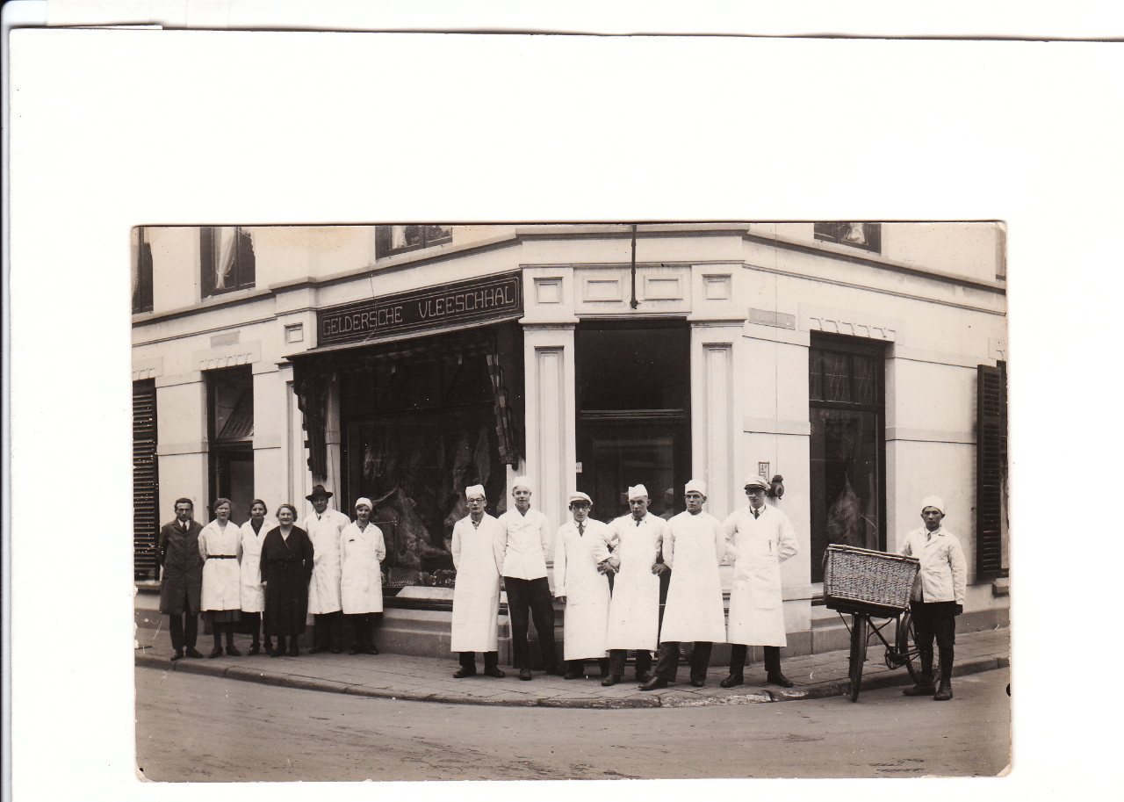Geldersche Vleeschhal. Winterswijk.
Left in dark dress: Henriette Blom-Gans, next to her with hat Willem Blom.
Blom children and personnel.

